Project Synopsis

**Aim / Objective**

Hospital networking system using Cisco Packet tracer.

**Project Submitted To**

Assistant professor : Saurabh Singh

**Project Submitted By :**

**Abhishek Kumar**

**Vishal Pandey**

**Ziaul Hassan Khan**

**Priyanshu Maurya**

**Ark Barua**

INTRODUCTION

Computer networks are considered to be very complex and difficult to implement and operate. Moreover, with IoT (internet of things) technology, where we connect any sort of devices on internet such as refrigerator, air conditioner, fan etc. this complexity becomes even higher. Many documents show that there are actually 13 billion IoT (internet of things) devices connected to the internet, and that there is a possibility that this number will go up to 30 billion in the next three years.

This complexity of the network will give students some though time for learning and understanding how this technology work. Therefore, it is very important to provide a network learning and practical tools, where student can simulate or build and manage the systems for better understanding of the philosophy behind networks.

Network simulation tools are used for testing how the network will work before being physically installed. There are many tools for network simulation: NS-2, TOSSIM, OMNeT++, J-Sim, Avrora, and the common one Cisco Packet Tracer.

Cisco packet tracer is a powerful software created by Cisco Company for simulating virtual networks, especially wireless networks. Cisco packet tracer gives an environment where devices look what they do in reality, and this is very important for users especially students. They can monitor and interact with different wireless and IoT devices in virtual environment before working in real time.

Working with simulation tools to learn how networks work give us both time and materials advantages and help decreasing the costs in education.

This thesis is organized as follows: the first part of the thesis is the introduction, the second part is focused on cisco packet tracer simulation tools, the third part of the thesis is about the implementation of smart home with cisco packet tracer, and the last part is conclusion and future research.

# IoT definition

Internet of things or internet of everything refer to the idea of thing (object), that are readable, recognizable, locatable, addressable through information sensing devices (sensor) and controllable via internet.

Things are physical objects with unique identifiers that are able to transfer data over the network. Examples of physical objects include vehicles, smart phones, home appliances, toys, cameras, medical instruments and industrial systems, animals, people, buildings, etc.

Internet of Things is a new revolutionary and advanced technology where any object becomes smart object, and where they can communicate information about themselves without human intervention. The Internet of Things is expected to make a huge change in our lives; it will help us to perform our tasks and duties in a better way.

# Internet of Medical Things (IoMT):

The medical sector will be the one to benefit the internet of things technology the most.

Internet of things in healthcare give the possibility to the doctors possible to control patient conditions anywhere anytime over network in order to provide monitoring, analysis and remote configurations through smart devices such as heart monitors and pace makers. Many others internet of things devices can be used to control our health such as fitness trackers and smart watches etc.

# CISCO PACKET TRACER

**Cisco Packet Tracer Overview**

Cisco packet tracer is a powerful virtual network simulation tool used to learn and understand different concept in computer networks. The tool is developed by Cisco in order to allow students or user to get practical networking technology knowledge. Cisco packet tracer provide user / student to design and simulate a network by using virtual devices such as hub, router, switches etc. In cisco packet tracer, the simulation works without having any physical network.

# Packet tracer Workspaces:

Cisco packet has two Workspaces: one is Physical and the other one logical. The logical view allow user to place and connect virtual network devices while the physical view gives a graphical representation of the virtual network devices. In the physical view of the devices, we can add additional modules to an available slot in the devices The good thing about this particular simulation tool is that it provides an environment where devices resemble to devices in the real world. This is very important because it give user the possibility to be familiar with devices before working with the real equipment.

# Packet tracer Mode

The tool also provides two modes, which are real time mode, and simulation mode. In the real time, students/ user can have a clear vison of how the devices behaves. In this mode, devices behave as real devices. In the other hand, the simulation mode help students / user to understand the fundamental concept behind the network operations. This mode permit user to see and control time intervals, and to visualize the propagation of data across a network

# Cisco devices configuration methods

Cisco packet tracer allow us to configure devices using two options: config tab or CLI tab (command line interface). With command line interface, we configure devices using cisco command line. The advantage of using the command line interface is that, the commands we use to configure devices virtually are the same command we use with the real devices.

The config tab did not require any cisco commands knowledge. Configuration with config tab is done through a graphical interface. This configuration method can be use in the situation where user does not have enough time and want to configure devices quickly. This technique can help us saving time during configuration.

# Cisco packet tracer supported protocols:

Cisco packet tracer support different protocols. The table below show the lists of protocols supported by packet tracer.

**Devices Used**

1-Router (1841) – 3

2- switches (PT Switch) – 6

3- System (PC) -10

4- Server (PT Server) – 2

5- Cable (DTE Cable, Cooper straight through)

6- Home Gateway (DLC 100) – 2

7- Smart Phone (PT Smartphone) – 2

8- Fan , Light , Door – 2

**DEPARTMENT**

1-Reception Desk

2- Parking

3-Doctors Cabin

4-Chemest Shop

5- Server room

6-Male & Female Ward

7-Lab

PROJECT OBJECTIVE

Ours main moto is to connect all the department to each other to make work easier and keep the record in one place so it can be accessable for all the department in the hospital.

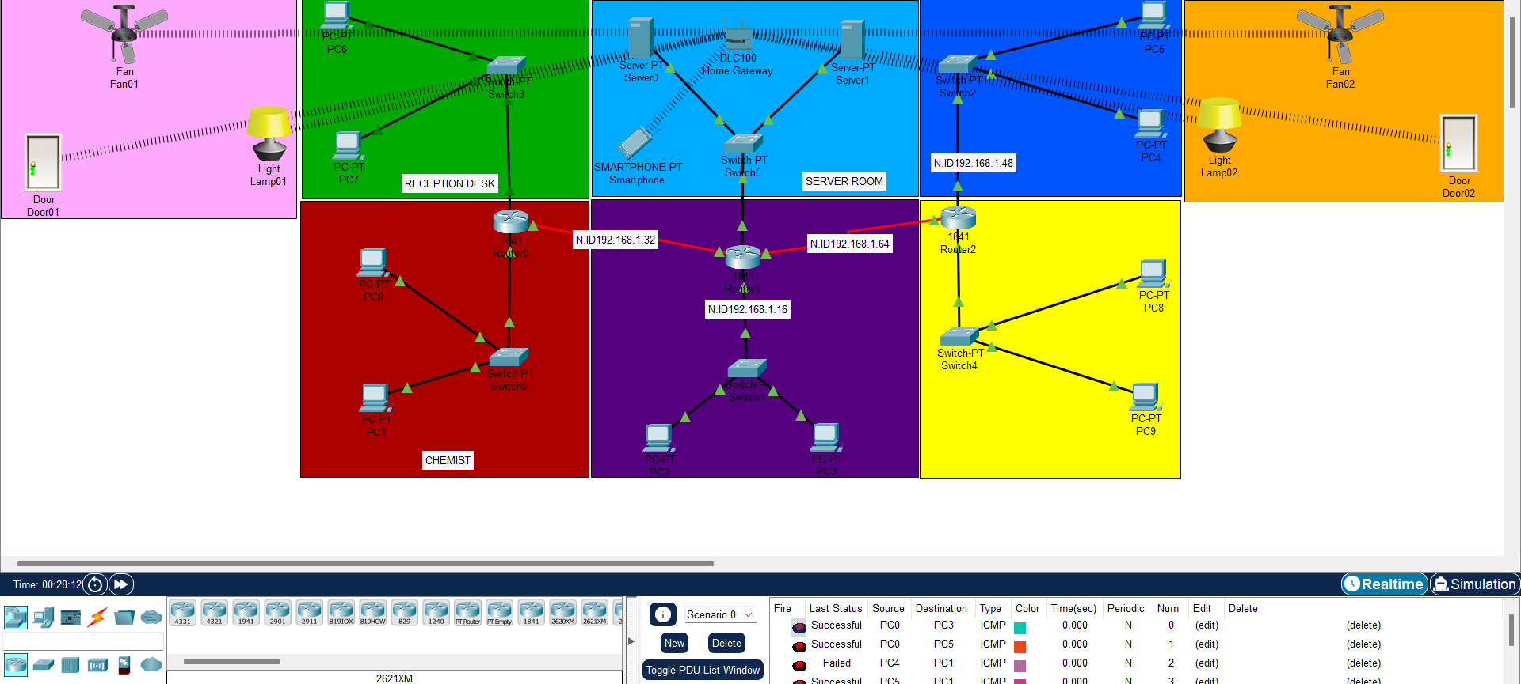

So, First we start with the parking who ever comes in to hospital first it will be noted and the data will go the server for safety regions, then the patients will go the reception desk where his name and all the verification is done. Doctor cabin where patients will go for check up and his check ups and everything will be done and all data of the patients will be entered it the system and it will directly save into the server. Testing Lab any test of the patients which doctor recommends will be tested in lab and report will be saved in the server as if doctor wants to see the report can request to server and it will send in to the doctor system. We have added chemist department were any one can directly send the request for any medicine it will be delivered to his/her ward. Their is 2 ward male and female which is a general ward were patients will be admitted

The ward is totally IOT which means every thing in that ward will be wirelessly connected and will be controlled via a mobile which will help them to control it easily from one place.every single data in the hospital will be send directly to server will help every one in the hospital to access it easily and data loss will not happen and can have all record at one place.

RECEPTION DESK

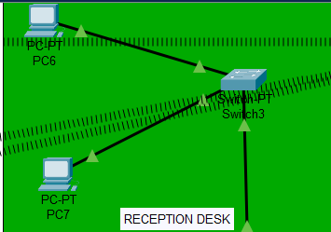

IN reception desk there is 2PC which is PC6 and PC7 , PC6 IP is 192.168.1.82/28 subnet mask 255.255.255.240

And PC7 IP is 192.168.1.83/28, 255.255.255.240 which is connected to a PT switch3 through straight thought cable and the switch connected to router (ROUTER0-1841)through straight through cable in FAST ETHERNET 0/1 and its IP address is 192.168.1.81/28,255.255.255.240 which is the gateway address. The gateways address through which one Network can send data to other’s Network so the PC6,PC7 gateway address is 192.168.1.81.

PARKING

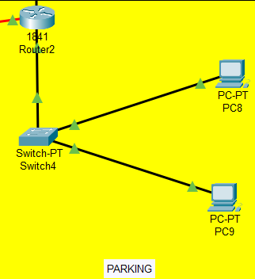

In parking there is 2 PC which is PC8 and PC9 who’s IP is PC8 192.168.1.114/28,255.255.255.240

PC9 192.168.1.115,255.255.255.240 which is connected to PT SWITCH4 with straight through cable and switch is connected to router (ROUTER2-1841) through straight through cable in port FAST ETHERNET 0/0 and its IP 192.168.1.113,255.255.255.240

Which is the gateway address of PC8 and PC9 which will send his data to server room.

CHEMIST

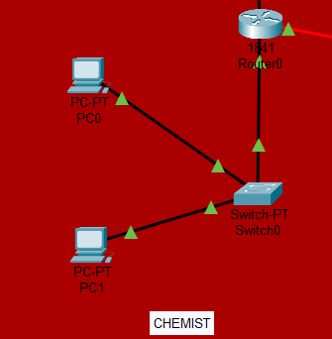

We have made a chemist department were any one can direct request a medicine which will be delivered to ward or cabin, chemist have 2 PC PC0 and PC1

PC0 is 192.168.1.2/28,255.255.255.240 and PC1 is 192.168.1.3/28, 255.255.255.240 which is also connected to PT SWITCH0 with straight through cable and switch is connected to router(ROUTER0-1841) to port FAST ETHERNET 0/0 IP is 192.168.1.1/28,255.255.255.240

Which is the gateway of PC0 and PC1.

SERVER ROOM

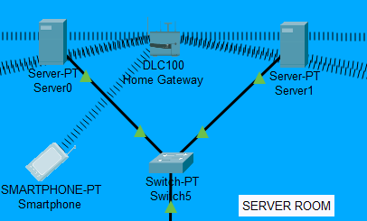

Server Room where all the data of the hospital will be saved and can be accessible to every department of the hospital and every department will send data to server were all the record is going to stored. Server room has 2 PT SERVER , Server0 ip is 192.168.1.98/26,255.255.255.192 and Server1 is 192.168.1.99/26,255.255.255.192 which is connected to the PT SWITCH 5 and Switch is connected to router (ROUTER1-1841) FAST ETHERNET 0/1 IP 192.168.1.97/28,255.255.255.240 which is the gateways of both the server.

TESTING LAB

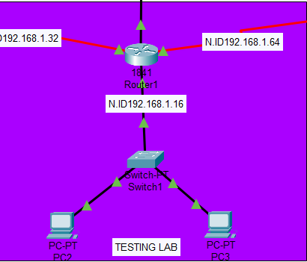

Testing lab where patients test will be held and report will be generated

WIRELESS DEVICES

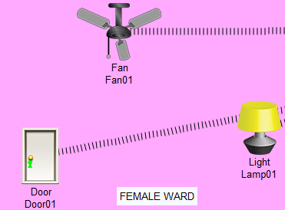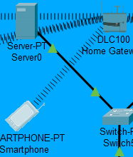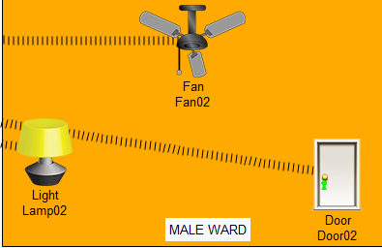

In this project we will now discuss about the wireless devices which are being used in the Hospital Networking System.

The Wireless Devices used in the System –

1. Ceiling Fan x2
2. Smart Door x2
3. Lamp x2
4. Smartphone x1
5. Home Gateway Device (DLC100)

Here, we have shown how these Devices are wirelessly connected to each other which is also known as IOT. The Smartphone will be able to control the power ON/OFF the above-mentioned devices excluding Smartphone and Home Gateway wirelessly in the Male and Female-Ward Room.